**PIC24 System Schematic Creation in PCB Artist**

**2nd Laboratory Report for ECE 383**

**Microcomputers**

**Submitted by**

**Shomari Thomas**

**11672867**

**Yichen Huang**

**11906882**

**The University of Alabama**

**Tuscaloosa, Alabama 35487**

**January 29th, 2020**

**Abstract**

This laboratory experiment was designed to teach the basics of creating PIC24 schematics in PCB Artist. The first task involved creating a basic PIC24 power circuit. The second task involved taking the design of the first task and converting it into a printed circuit board design. The third task involved taking the design of the first task, and adding to it to create a basic PIC24 system schematic. The fourth and final task involved taking the design of the third task and converting it into a printed circuit board design.

**Introduction**

The objective of this lab is to become more familiar with the PCB Artist program, and how it can be used to create PIC24 circuits and system schematics. Task one has us create a basic PIC24 power circuit schematic, using the PIC24HJ128GP502 microprocessor, based on a given design in the lab document. Task two has us take the circuit schematic created in task one, and convert it into a printed circuit board layout. Task three has us creating a second PIC24 circuit schematic, based on the first schematic from task one, but with added resistors, an LED, and a pushbutton to create a basic PIC24 system schematic. Task four has us take the system schematic from task three and convert it into a printed circuit board layout.

**Procedure/Results**

Task one had us create a circuit in PCB Artist based on a design from the lab handout, that effectively created a basic PIC24 Power circuit.

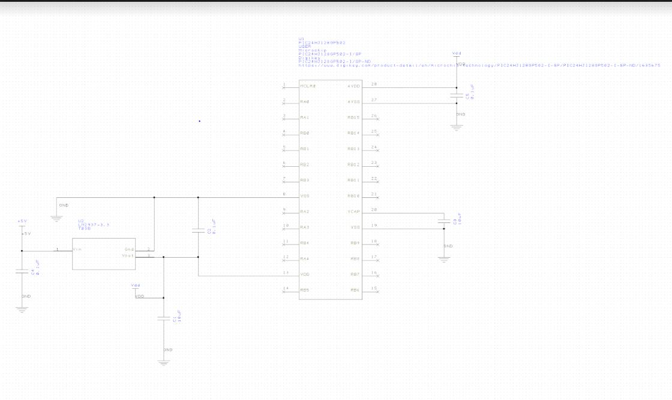

Task two had us take the design of task one, and convert it into a printed circuit board layout. 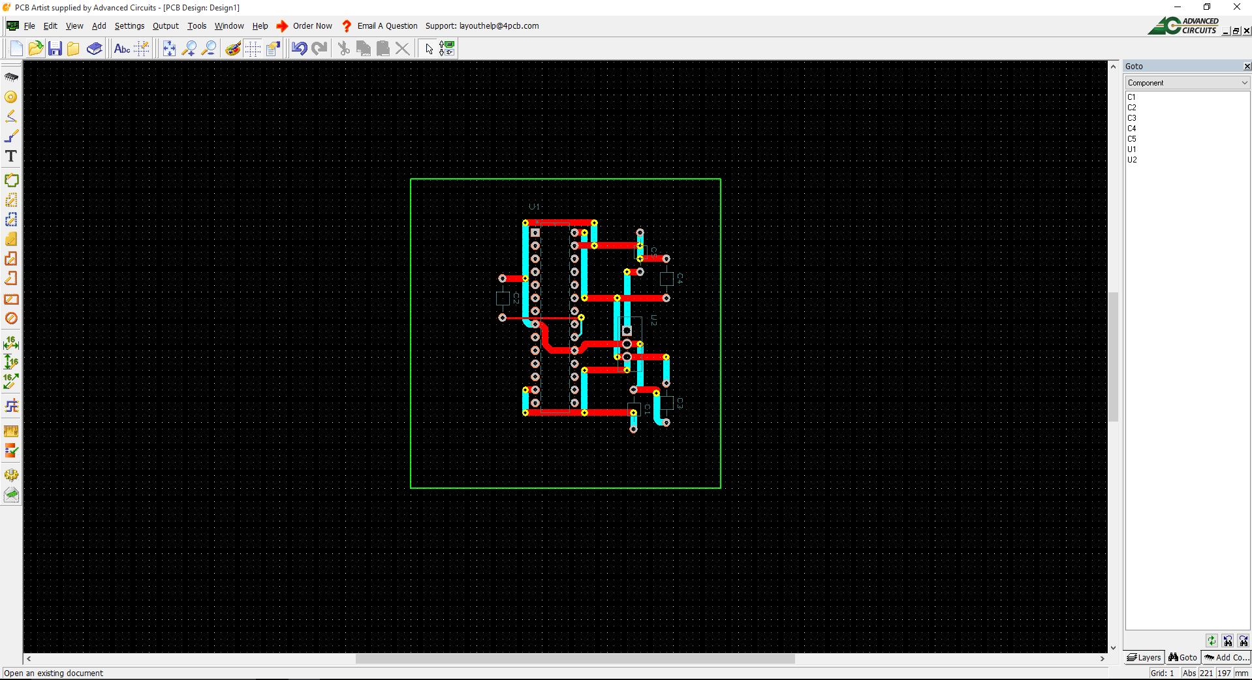

Task three had us create a new PCB design, based off of the first one using resistors, an LED, and a pushbutton for a basic PIC24 system design.

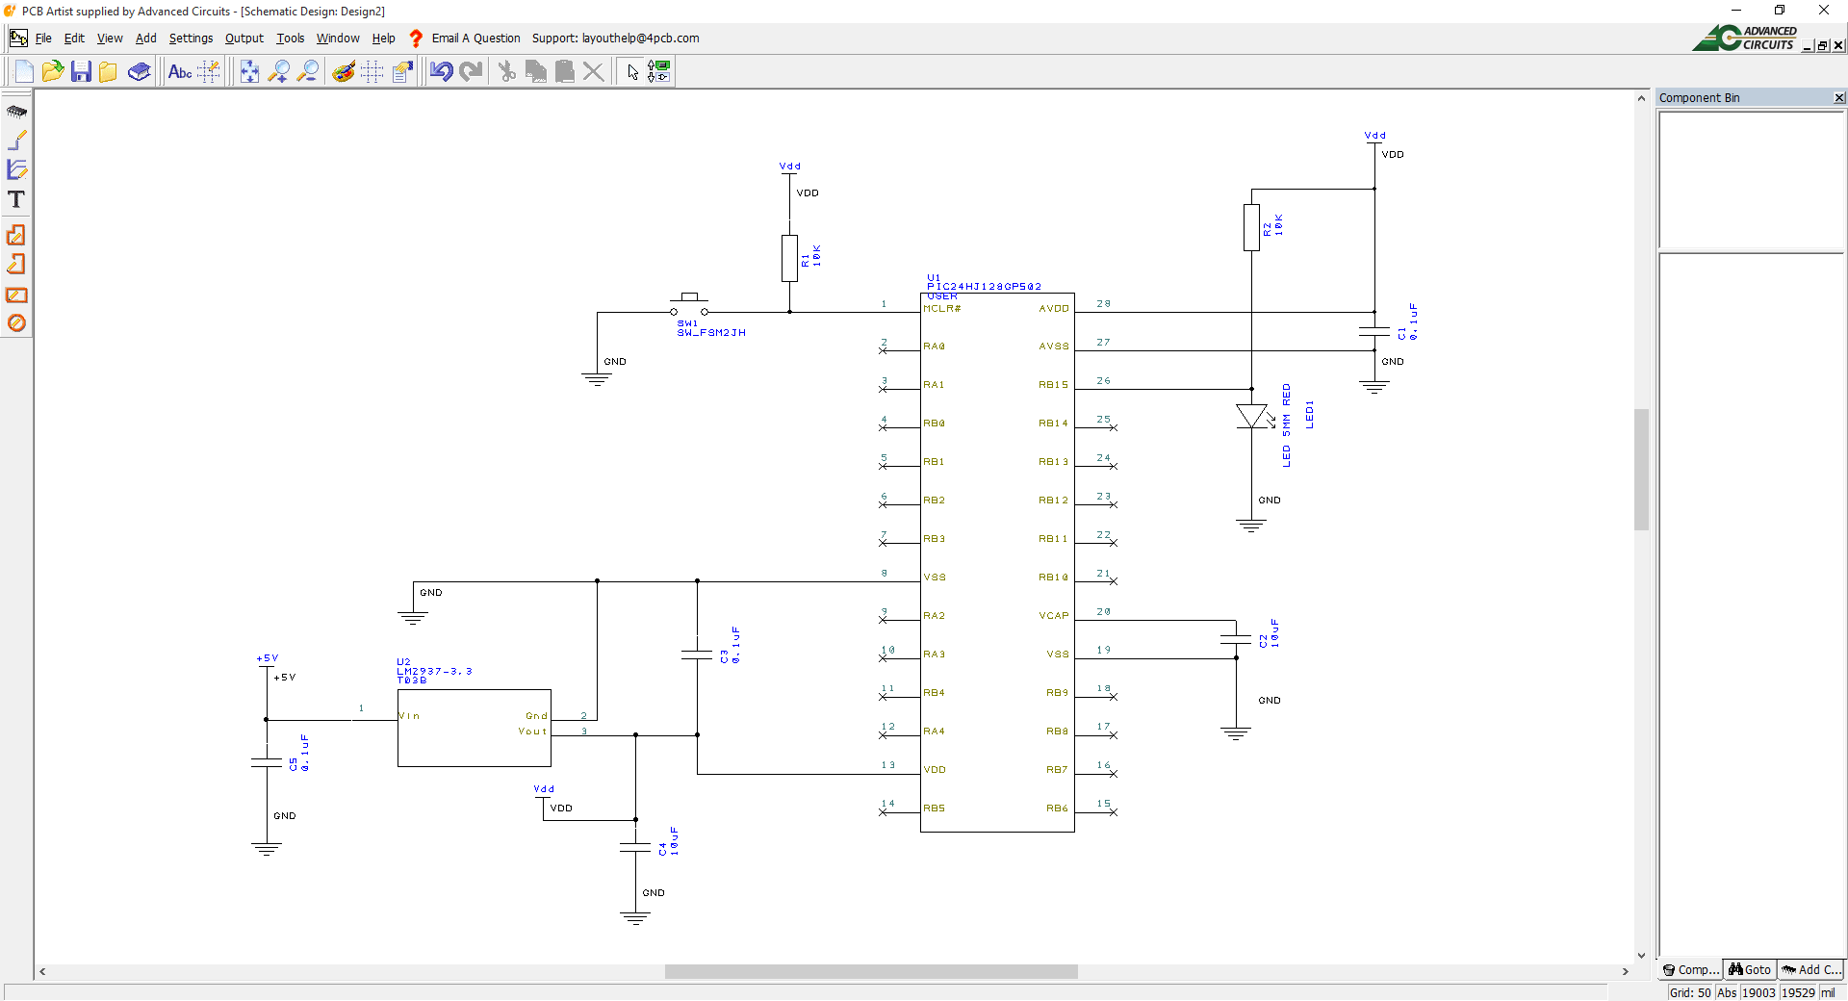

Task four included taking the design of task three and converting it into a printed circuit board design.

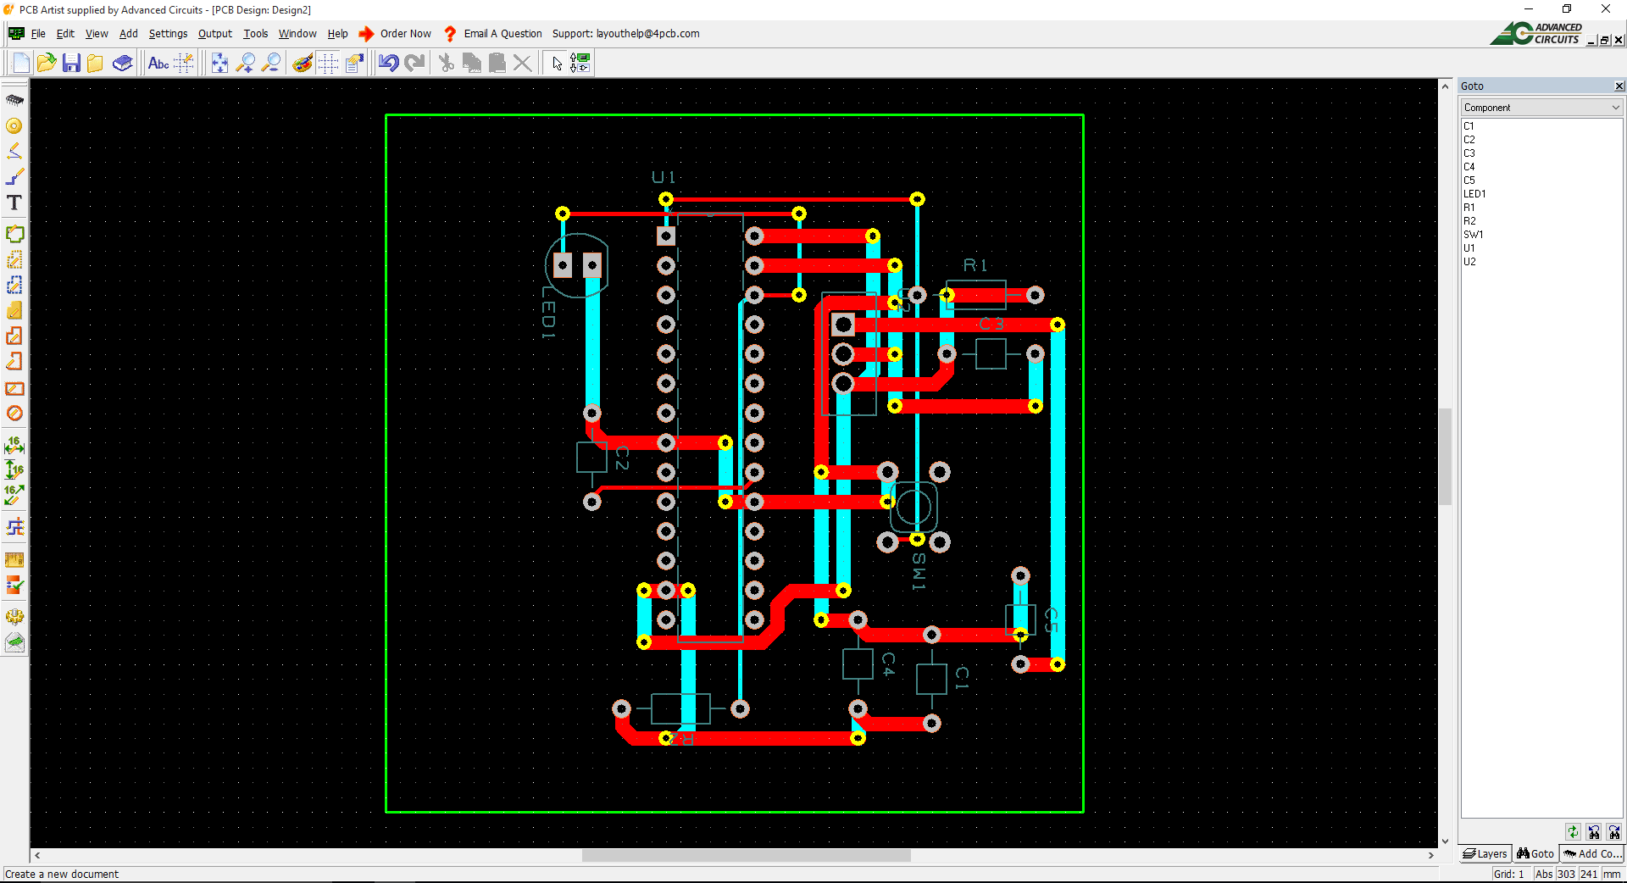

**Conclusion**

This second lab was a learning experience for the PIC24 circuit schematics, and a further learning experience for the PCB Artist Program. We were taught how to create a basic PIC24 power circuit schematic, and how to create a basic PIC24 system schematic. We now know how to properly create these two designs, and how to translate them into printed circuit board designs, and which libraries to access when building these designs. Overall, we now have a better understanding of PIC24 circuits and printed circuit board designs.